THE HB63C09M

The Auto Staging HD63C09 Playground

Designed by David Collins (Z80Dad)
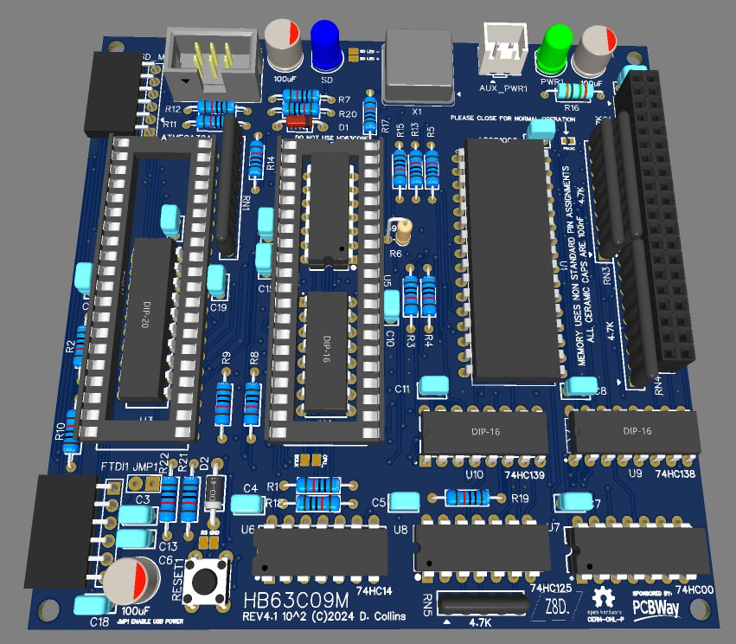

A Portion of Development Costs Sponsored by


Development:

The HB63C09M is a project I stared back in June of 2023. I had done some experiments running an Atmega AVR micro controller in tandem with a 6809 cpu, very much in the vein of Brad Rodriguez's Scrounge-master, that he started talked about in his paper “Multiprocessing for the impoverished in The Computer Journal #63 (Sep/Oct 1993)”, and Fabio Defabis’ Z80-MBC2 – these two designs laid the groundwork for what became the very simple request / grant design that lays at the center of the computer itself:

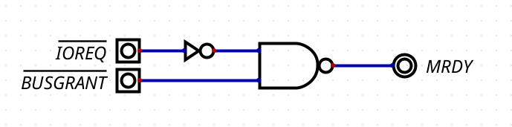

This very simple circuit (along with a fully synchronized clock with the AVR, allows for 99% of the 8 bit bus arbitration to be achieved. By simply holding over the CPU, until the AVR is finished similar to the way a chess timer works.

This has some limitations, firstly, the entire IO range generates a clock stretch. This is mostly solved by the micro controller checking for a mezzanine request to inhibit the the AVR (ie the request is coming from off the board or in a externally mapped range from within the 4k IO range.)

Additionally there is a hard limit on how long the internal registers, which are dynamic can be held over. The data sheet specifies 5uS, this is still quite a long time. So this means as long as the AVR can do whatever it needs to do and pull /BUSGRANT low before the end of 5uS everything just works.

There are additional gates and buffers that handle various aspects of stability, but in general the bare minimum to create this kind of multiprocessor system is merely two chips. In fact – its also hugely possible to use an AVR with a large number of IO pins space to simulate the whole chip-set and memory --- just so long as all the transactions are less than 5uS

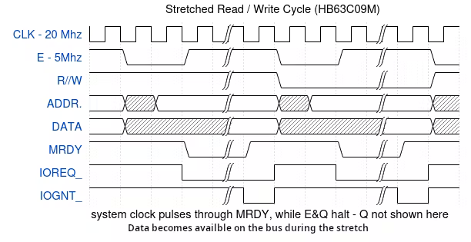

Memory Map and Banking

Address Ranges
The memory address space is segmented as follows:
- ROM / RAM Configuration
  - B000-FFFF: Upper Fixed Ram 20K Physical Rom Space
  - A000-AFFF: Device Address Space for MCU
  - 4000-9FFF: Lower Fixed 24K Fixed Lower Ram Bank
  - 0000-3FFF: Memory Bank Window, set by bank register (16K)
- 128K RAM Chip Layout (Banked)
  - Each bank represents a segment of the total 128K RAM available, selectively accessible through a banking mechanism controlled by a bank register.

Bank Select
The system uses a bank register to select which 16K bank of RAM is accessible in the memory window 0000-3FFF. The bank selection is controlled by a 3-bit value, enabling up to 8 different banks (0 to 7) to be selected. Banks are accessed by writing a value to 0xA03F, the last value set to this register can be determined by reading the same location. There are 7 banks 0 – 7 Special Memory Regions
- Bank 0 and Bank 1 (Lower Fixed Ram)
  - bank 0 is a traditional bank containing the bottom of ram in the 128k ram chips physical address space.
  - Bank 1 contains shadow space of the fixed banks bottom 16K.
- Bank 2
  - Lower Fixed RAM Shadow Space: 0000-1FFF within the bank space is shadow of the top of the 24k lower fixed RAM bank at 8000-9FFF, be careful to not overwrite this space unintentionally.
  - Usable Space: 2000-2FFF 4K within the bank address space is usable. This is the physical space in the RAM chip “behind” the IO range.
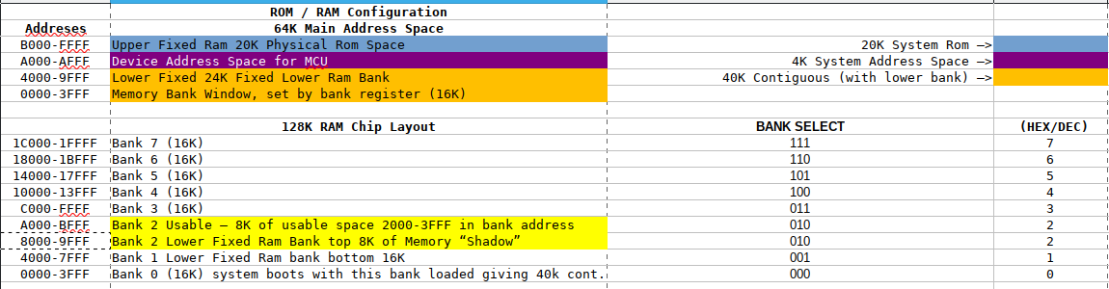
  - Upper Fixed RAM Shadow Space: 3000-3FFF within the bank space is shadow of the bottom of the upper fixed ram (space) C000-CFFF, be careful not to overwrite this unintentionally.

REV 1 Prototype

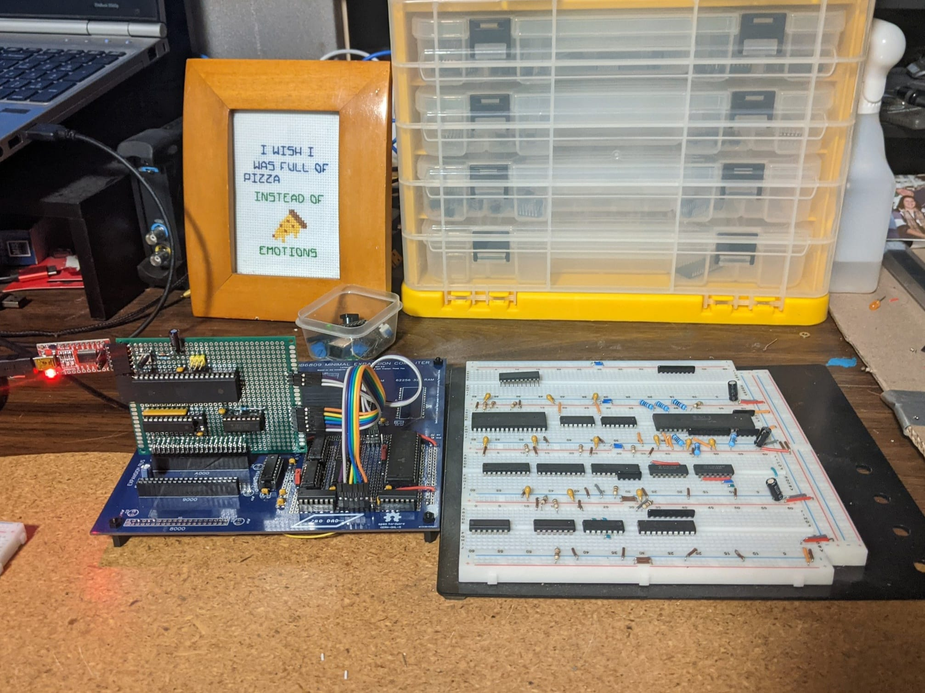

The Rev1 prototype was built on a bread board, and across two plated through hole sections on multiple PCB’s using a spare HB6809 Hackable Expansion computer PCB (this was a computer I had designed a year earlier) The large space provided by the micro ATX sized PCB allowed for me to really have the space to build as I saw fit. There were multiple hand wired lines on the back sides of both PCBs.

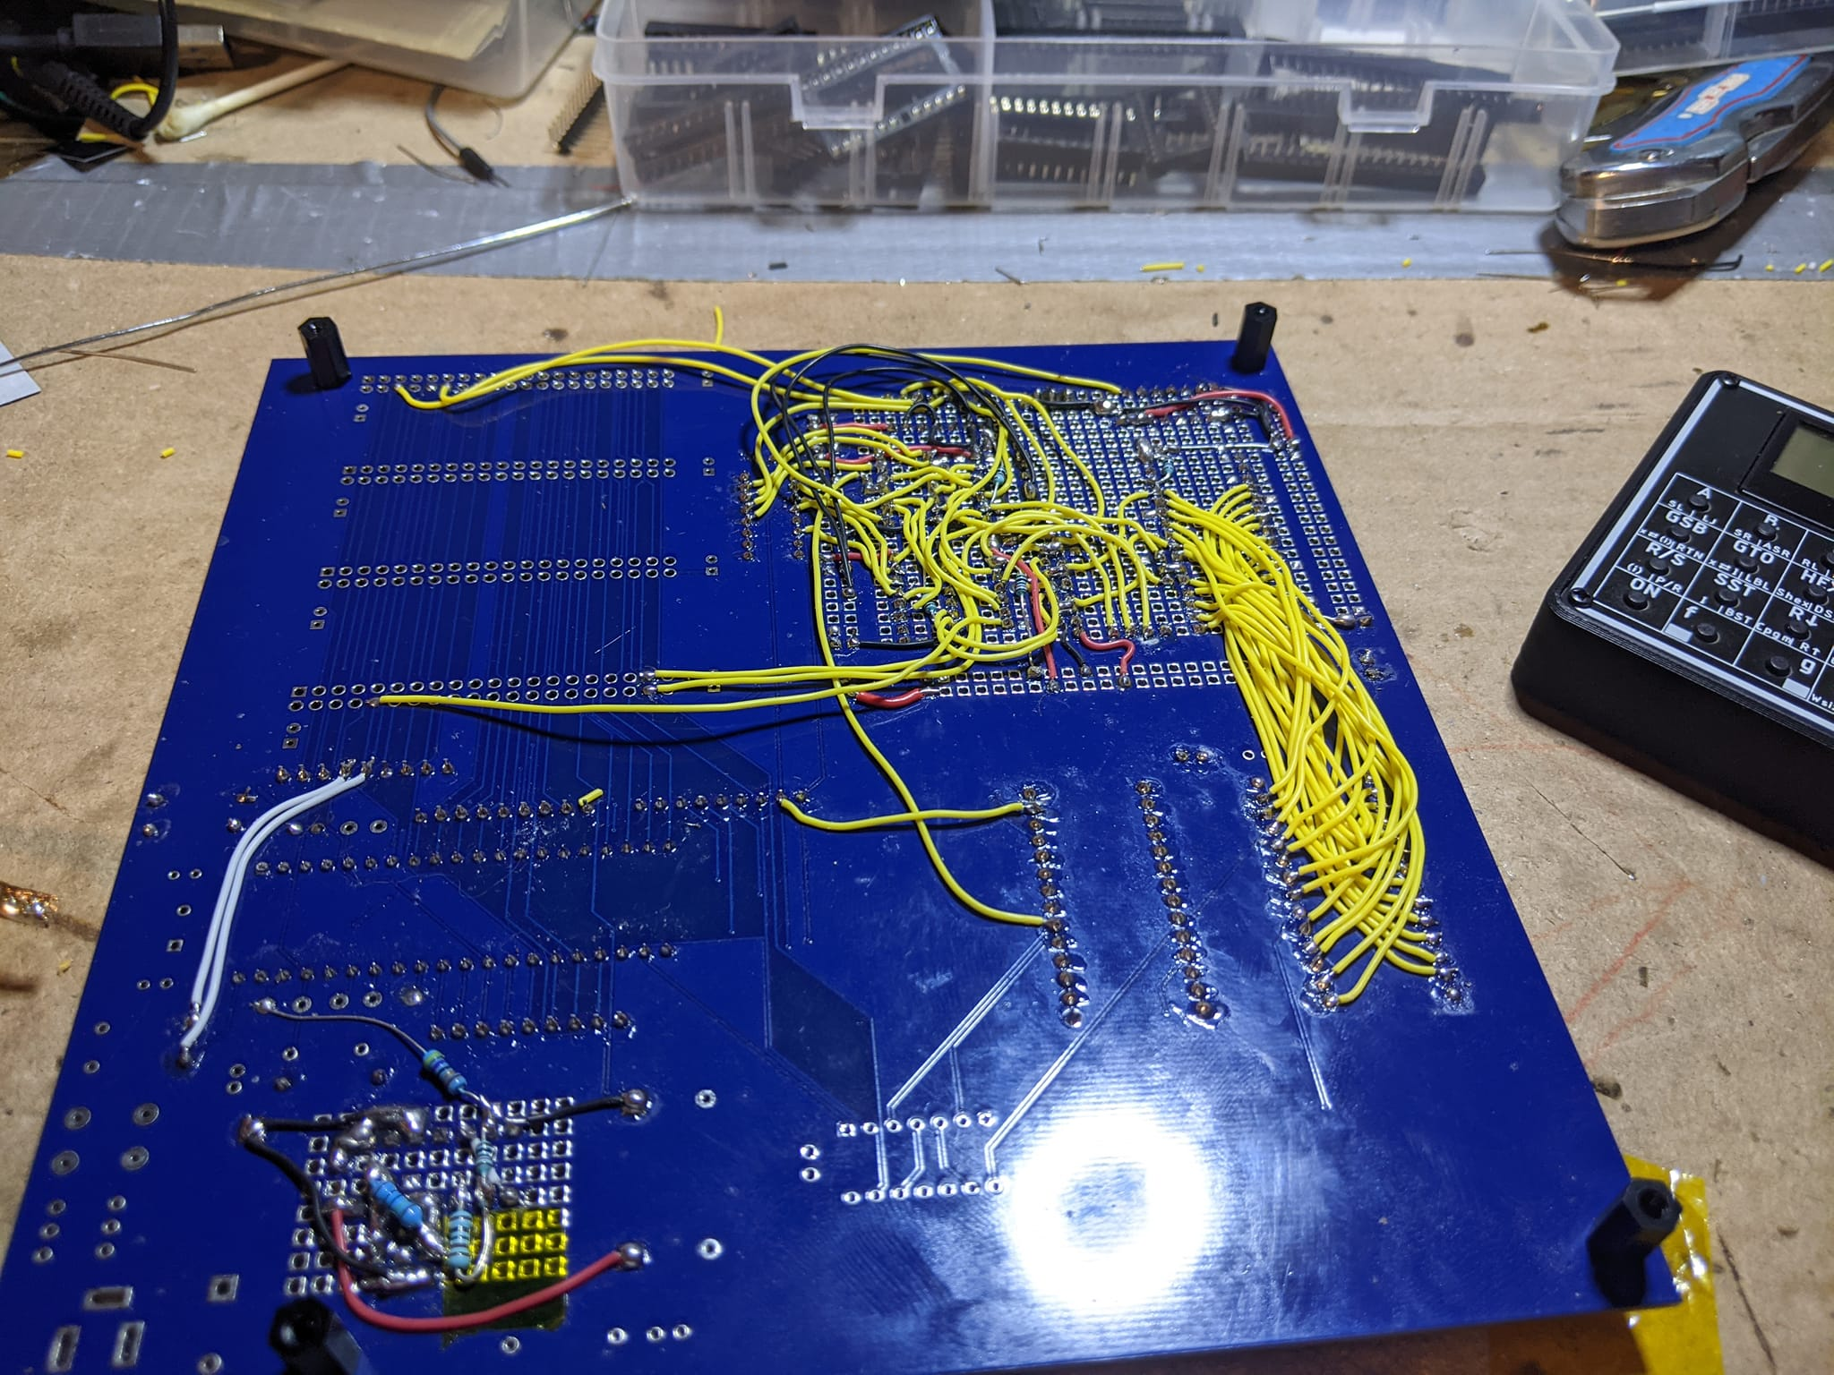
The Purpose of REV1 was simply to test timing and scaling, and while it had the guts of the HB63C09M it had no real way to use the higher end serial formats such as I2C and SIP I would need to load from an SD card, which was the ultimate goal.

I moved on very quickly to REV2 which had several lay out issues and the board didn’t really work. Learning from that process was very time consuming, but I was able to get things going with REV3.

REV3 Prototype

The Rev 3 was the fist functional ATX sized PCB. Almost exactly as the release version of the PCB however it was switchable between RAM and ROM boot space. The goal of this design was to create a nearly ringing free large format PCB to really test the capability of 20Mhz synchronized clocks. These tests were sucsessful but I was till not pleased with the build cost and the chip count. I wanted something that resembled Fabio Defabis’ Z80-MBC2 in the 10x10 cm form factor. By eliminating the logic for the ROM, having completed the software to stage from SD, and by repurposing a few unused gates, I was able to get the chip count down from 12 to 11 chips. Which is still quite densely packed for a 10x10 PCB.
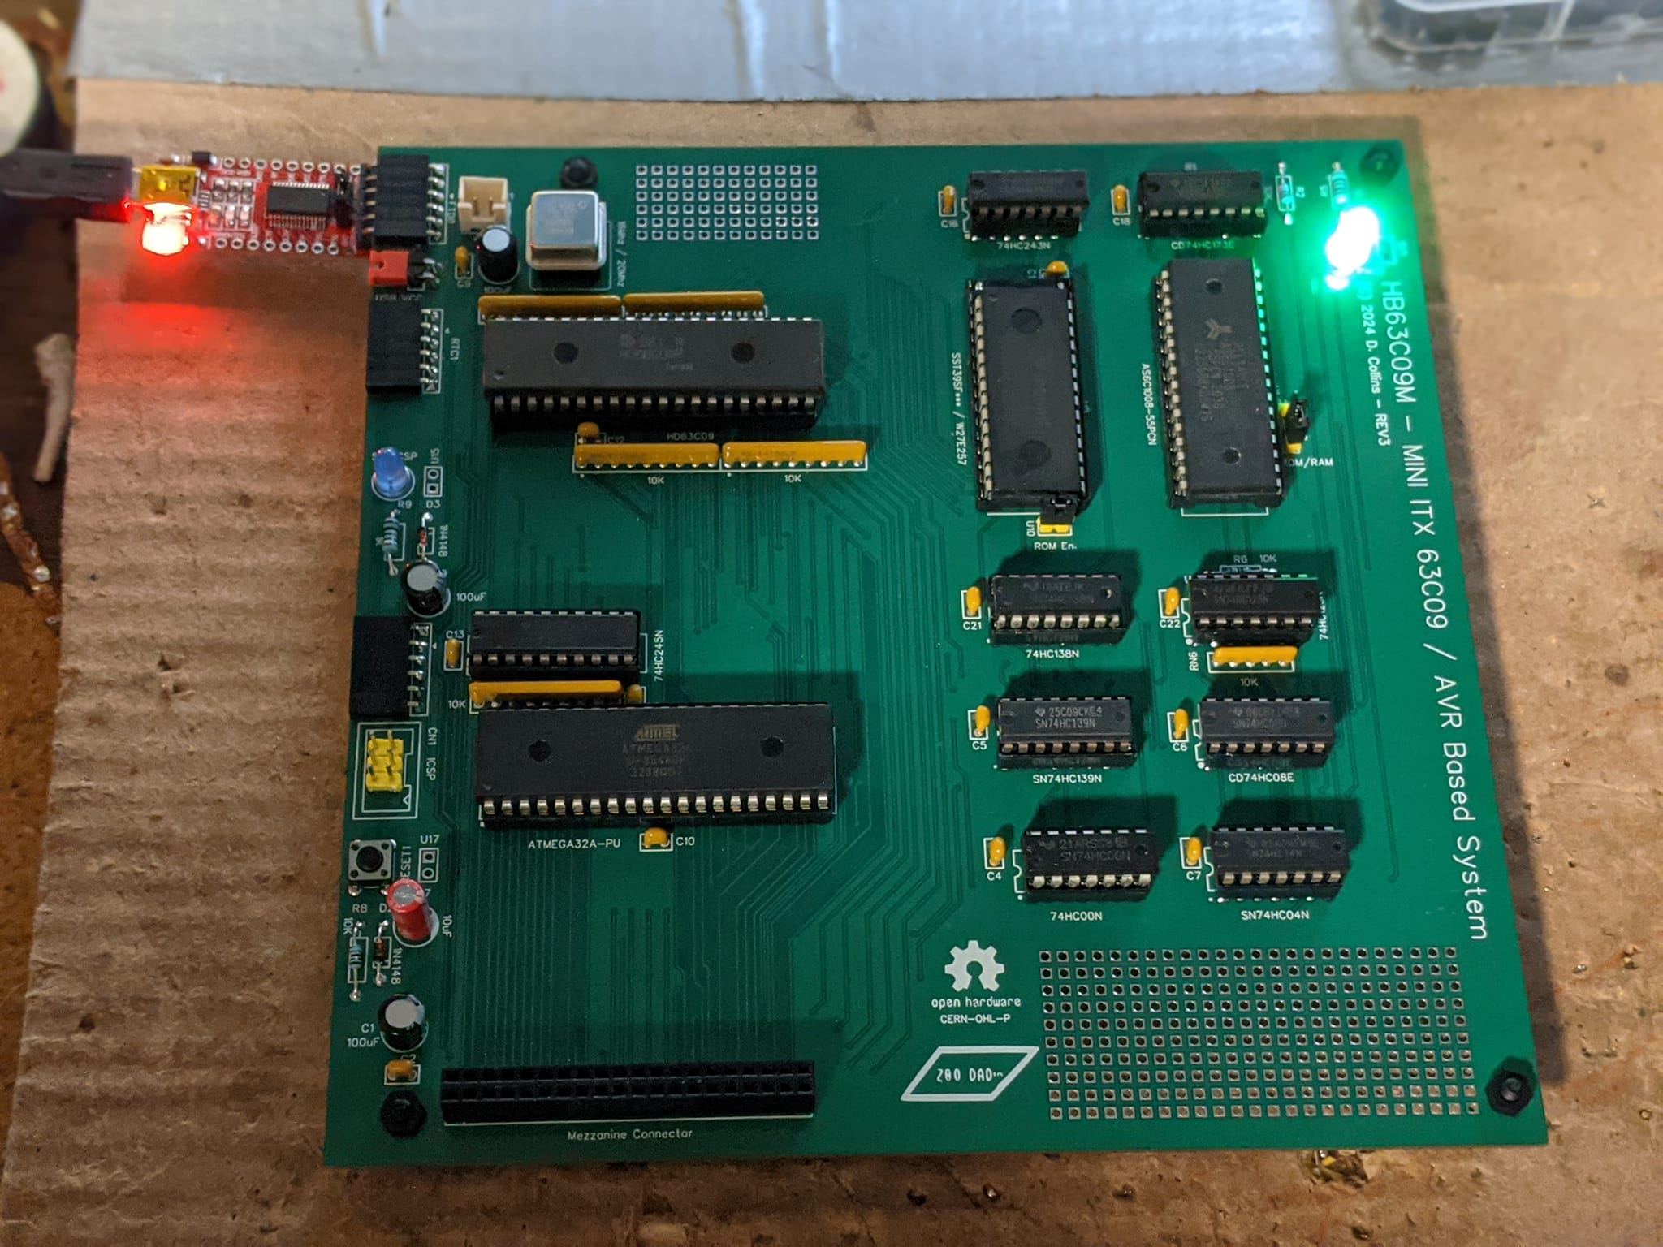

REV 4 Prerelease Version

REV4 is a 4 layer, 10x10 through hole PCB. There were a few hiccups with ringing and edge rate issues, but these were solved by changing some of the pull ups and adding a dampening resistor to the E clock line where it comes from the main CPU. A few changes to the mezzanine connector to bring out the buffered /RD and /WR lines which allow for reading and writing to the ram chip. As well as prearranging the signals location on the connector so that everything could be successfully routed. Significant work went into getting the most out of the unused space on the PCB for power and ground planes. The number of total vias in this design are significantly larger than any of the previous designs.

The “Pre” in pre- release is, a statement that moving forward were confident that no major changes to architecture will be needed, and I am confident that once the documentation is completed in the coming week or so the hardware design should be ready for release. However there is still a long way to go on the software side. There are still several pieces of software which need to be ported to the memory map, and some additional functions and features which need to be added to the firmware.

The basics are all there and ready to go, Fabio Defabis’ wonderfully minimal IOS firmware for accessing LBA disk images is 100% ported and converted to big endian for use with Motorola CPU’s. The vBIOS environment for staging and loading is complete and mostly working (a few minor things but mainly it is done). I would like to add a slightly different API for using i2c than is available on the Z80-MBC2 which allows for programmer to access i2c via primitives, as opposed to specific in built firmware which needs to be changed via a firmware flash to make changes. Adding a programmable interrupt timer is also a good idea. It may also be possible to add some floating point math operations to the micro controller if there is space.

But for other operating systems I think may be compatible with the architecture, Flex for certain – OS9 / NitrOS-9 Level 1 for certain --- maybe level2 (the banking system is very different from the CoCo’s.)

